

**REPORT**

On

**T TESTS AND CHI SQUARE TEST**

Submitted by

**EKANSH BARI**

**Registration No 11615973**

**(MGN909) Section KOE11 - A22**

**Programme Name: B.Tech Computer Science**

**School of Computer Science & Engineering**

**Lovely Professional University, Phagwara**

Assignment – **T TESTS AND CHI SQUARE TEST**

1. **Is there a significant difference between boys’ and girls’ fall reading scores?**

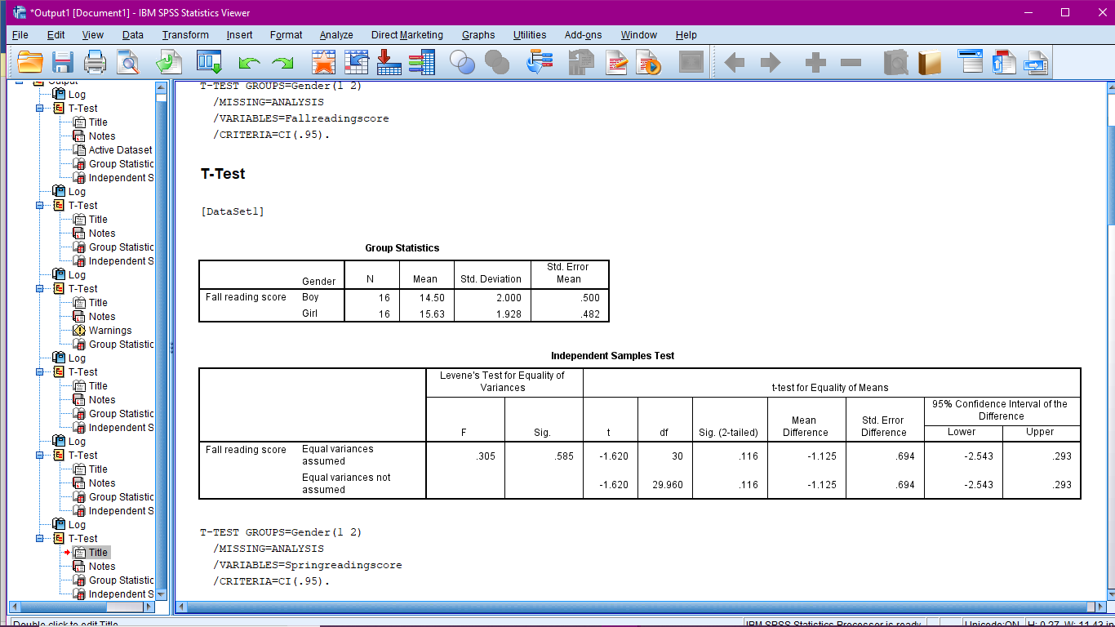

Mean score of boys = 14.50, SD =2.00

Mean score of girls = 15.63, SD = 1.92

*t* = -1.620, *df* = 30, *p* = .116

The significance (p) of the Levene test — the number in the second column — is high (greater than 0.05 or so), the values in the first row are applicable means here row one is valid.

The significance of the T test — that is, the two-tailed significance — .116 is greater than the .05 that means Null Hypothesis is accepted and there is no significant difference in the two means.

Conclusion: so here in this scenario there is no significant difference between boys and girls in the fall reading scores.

1. **Is there a significant difference between boys’ and girls’ spring reading scores?**

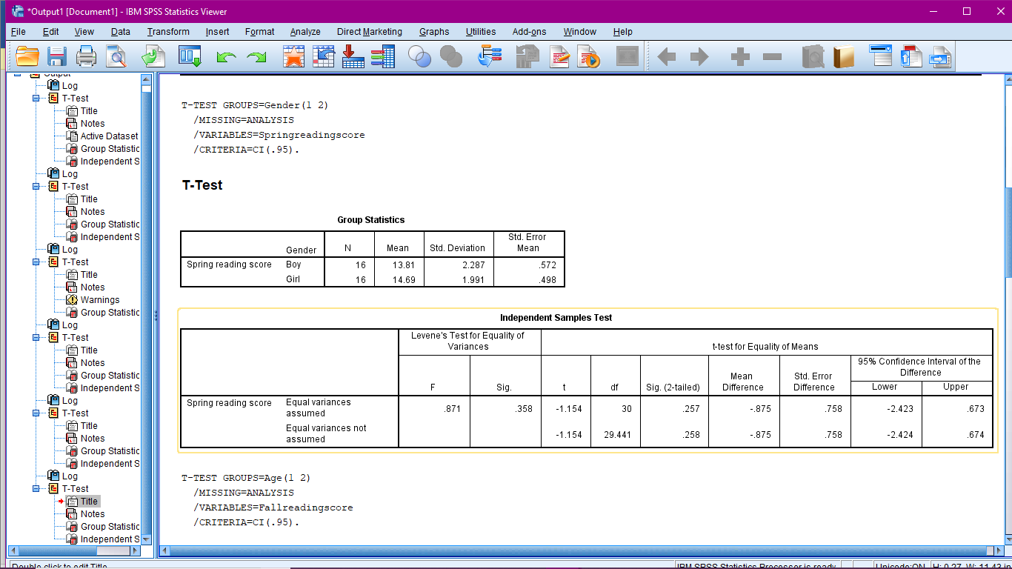

Mean score of boys = 13.81, SD =2.287

Mean score of girls = 14.69, SD = 1.991

*t* = -1.154, *df* = 30, *p* = .257

The significance (p) of the Levene test — the number in the second column — is high (greater than 0.05 or so), the values in the first row are applicable means here row one is valid.

The significance of the T test — that is, the two-tailed significance — .257 is greater than the .05 that means Null Hypothesis is accepted and there is no significant difference in the two means.

Conclusion: so here in this scenario there is no significant difference between boys and girls in the spring reading scores.

1. **Is there a significant difference between 6-year-olds’ and 7-year-olds’ fall reading scores?**

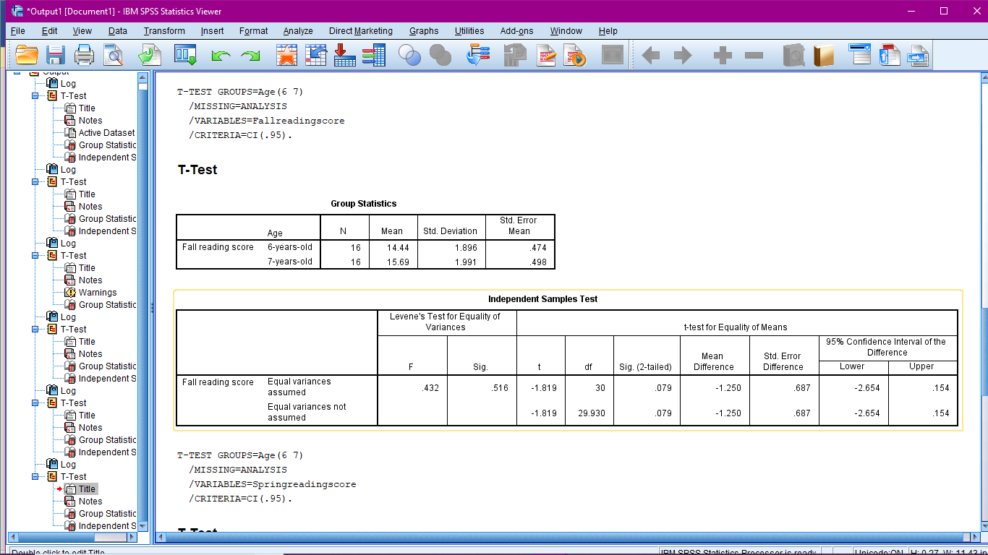

Mean score of 6-years-old = 14.44, SD =1.896

Mean score of 7-years-old = 15.69, SD = 1.991

*t* = -1.819, *df* = 30, *p* = .079

The significance (p) of the Levene test — the number in the second column — is high (greater than 0.05 or so), the values in the first row are applicable means here row one is valid.

The significance of the T test — that is, the two-tailed significance — .079 is greater than the .05 that means Null Hypothesis is accepted and there is no significant difference in the two means.

Conclusion: so here in this scenario there is no significant difference between 6-years-old and 7-years-old in the fall reading scores.

1. **Is there a significant difference between 6-year-olds’ and 7-year-olds’ spring reading scores?**

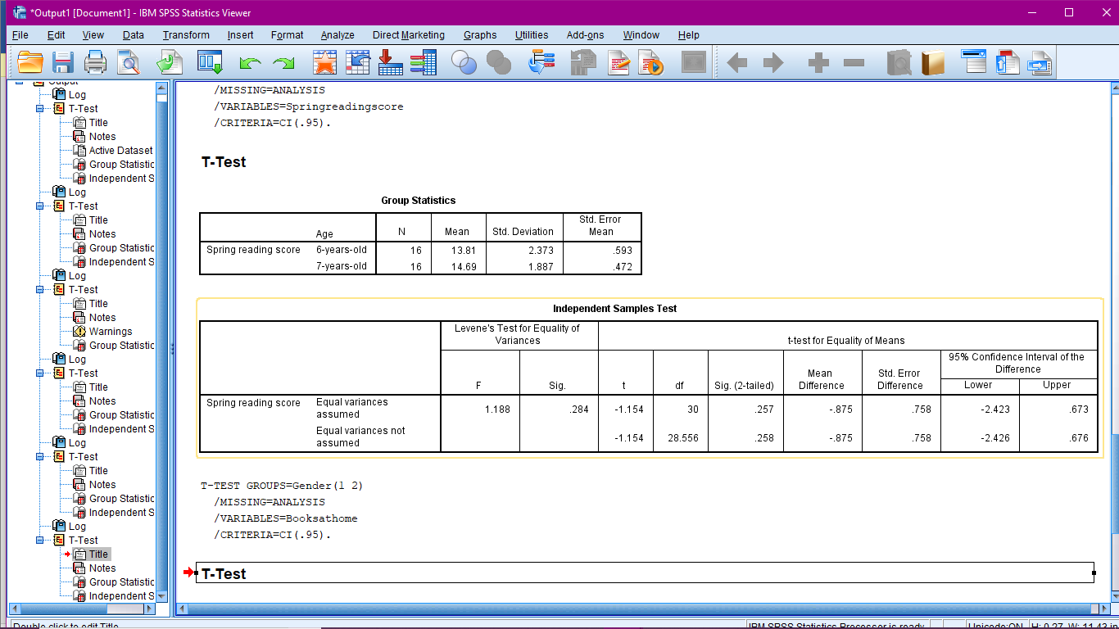

Mean score of 6-years-old = 13.81, SD =2.373

Mean score of 7-years-old = 14.69, SD = 1.887

*t* = -1.154, *df* = 30, *p* = .257

The significance (p) of the Levene test — the number in the second column — is high (greater than 0.05 or so), the values in the first row are applicable means here row one is valid.

The significance of the T test — that is, the two-tailed significance — .257 is greater than the .05 that means Null Hypothesis is accepted and there is no significant difference in the two means.

Conclusion: so here in this scenario there is no significant difference between 6-years-old and 7-years-old in the spring reading scores.

1. **Is there a significant difference between boys and girls with respect to the number of books in the home?**

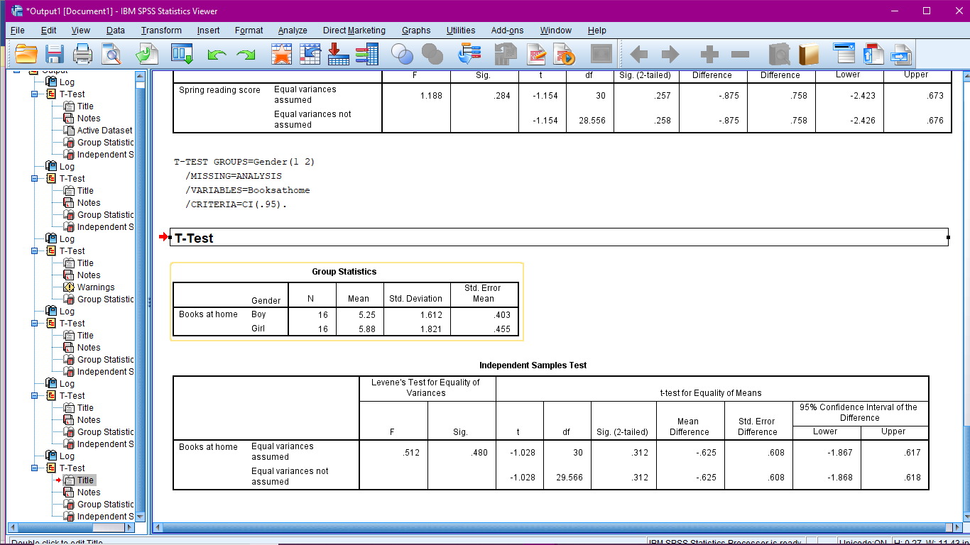

Mean of books at home of boys = 5.25, SD =1.612

Mean of books at home of girls = 5.88, SD = 1.821

*t* = -1.028, *df* = 30, *p* = .312

The significance (p) of the Levene test — the number in the second column — is high (greater than 0.05 or so), the values in the first row are applicable means here row one is valid.

The significance of the T test — that is, the two-tailed significance — .312 is greater than the .05 that means Null Hypothesis is accepted and there is no significant difference in the two means.

Conclusion: so here in this scenario there is no significant difference between boys and girls who have books at home.

1. **Is there any association between gender and flavour of an ice-cream is statistically significant or not?**

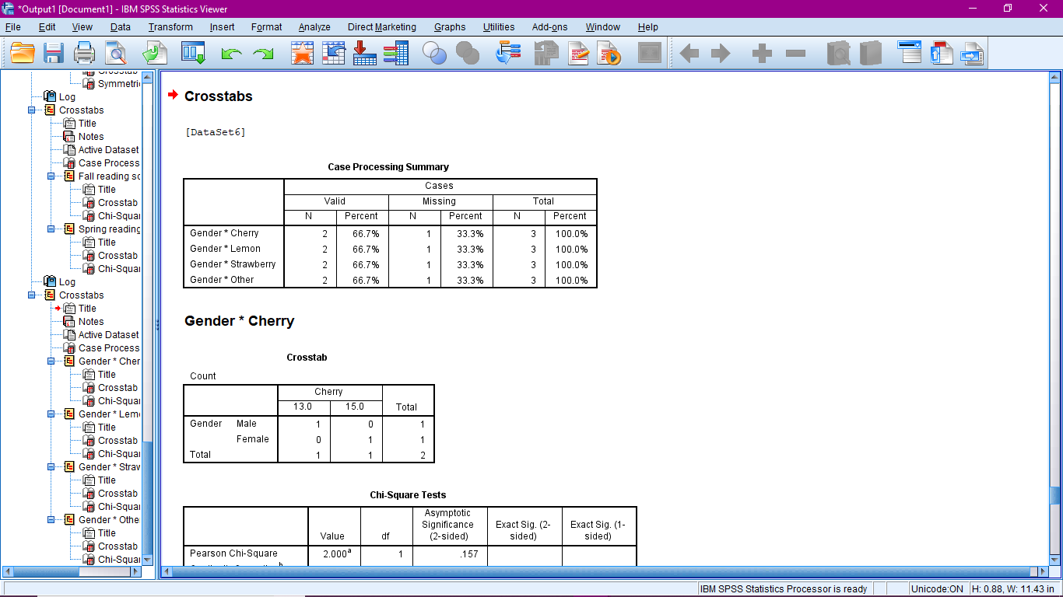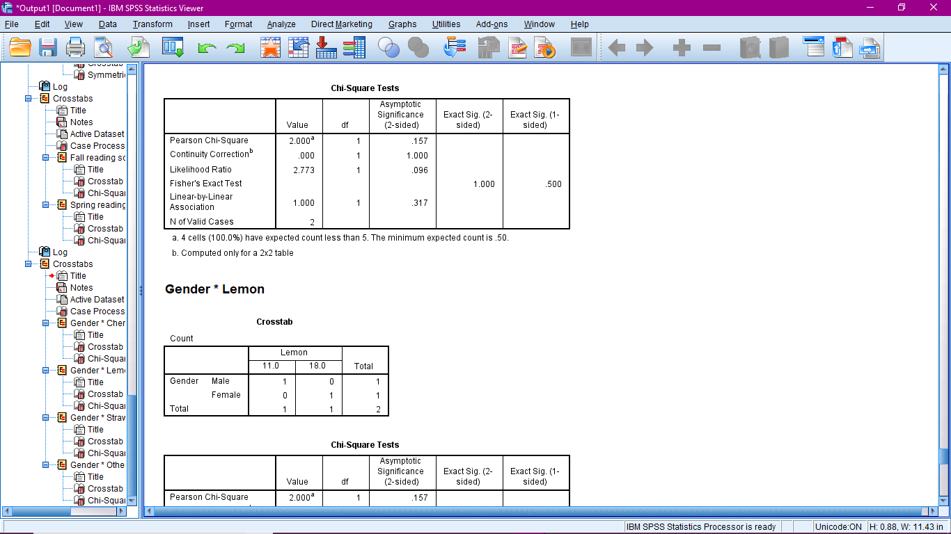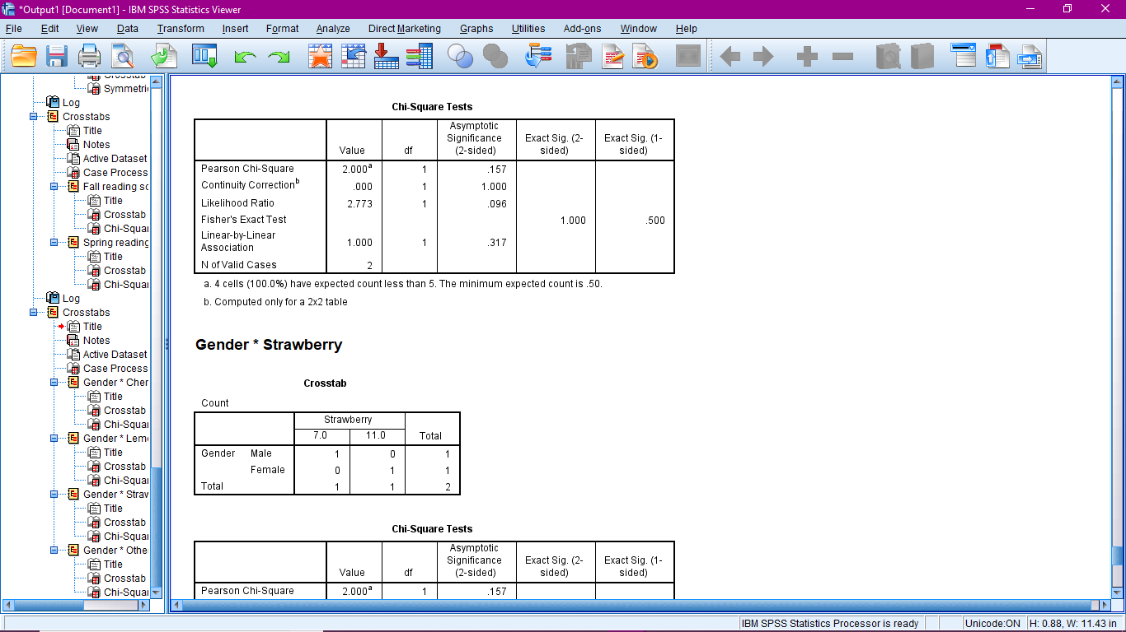

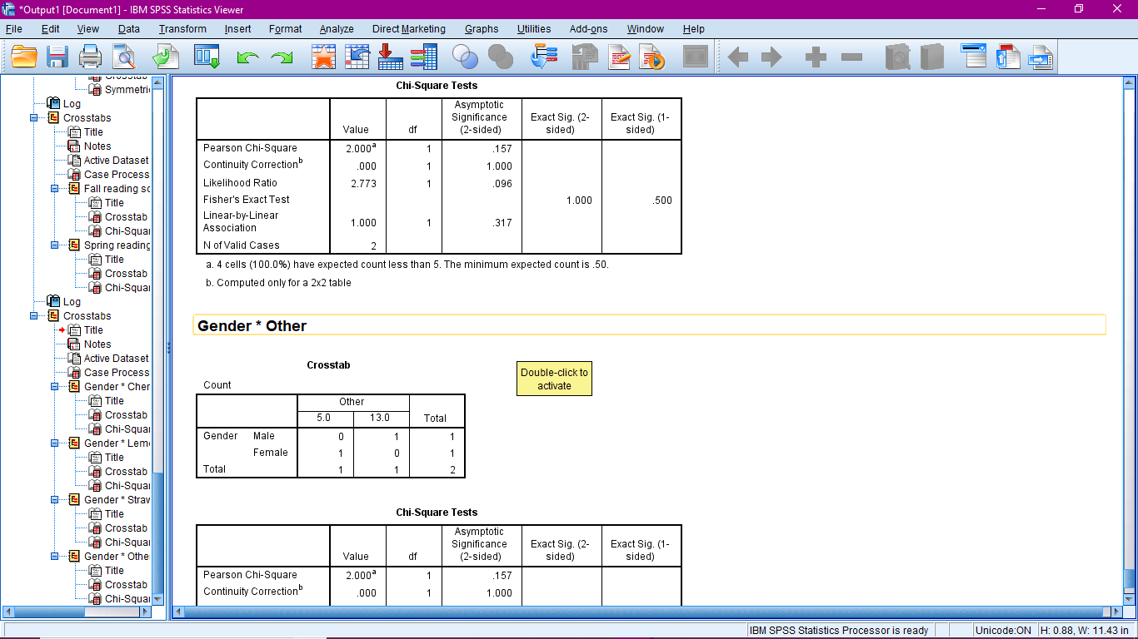

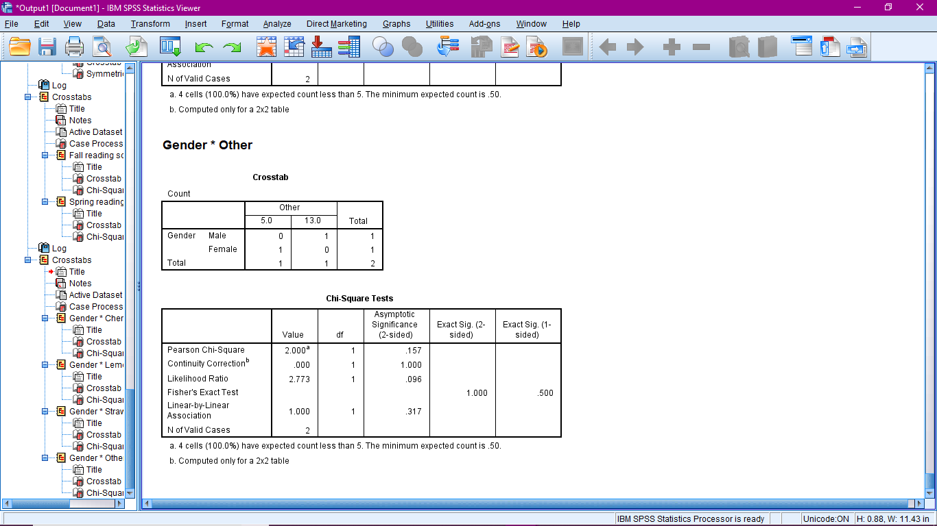

Here we have categorical data and so to find association we are going to apply Chi Square Test

1. **In all the scenario i.e. between gender*cherry, gender*lemon, gender*strawberry, gender*other**

We have the same values of p, D.O.F, Chi square value so the result or interpretation is going to be same for all the above four mentioned scenarios

P= 0.157, D.O.F= 1, CHI SQUARE CALCULATED VALUE = 2.000

Here the value of p i.e. 0.157 is greater than the 0.05 (5% significance level) that means our result is statistically not significant and we will accept the Null hypothesis that says there is no significant association among the data sample, that means our variables are independent of each other.

1. **State the appropriate conclusion for a chi-square test for goodness of fit for the given information**
2. **P= 0.10, D.O.F= 8, CHI SQUARE CALCULATED VALUE = 13.219**

Here the value of p i.e. 0.10 is greater than the 0.05 (5% significance level) that means our result is statistically not significant and we will accept the Null hypothesis that says there is no significant association among the data sample, that means our variables is independent of each other.

1. **P = 0.025, D.O.F = 17, CHI SQUARE CALCULATED VALUE = 27.008**

Here the value of p i.e. 0.025 is less than the 0.05 (5% significance level) that means our result is statistically significant and we will accept the Alternate hypothesis that says there is a significant association among the data sample, that means our variables is dependent on each other.

1. **Is the association between fall reading scores and spring reading scores with number of books is statistically significant?**

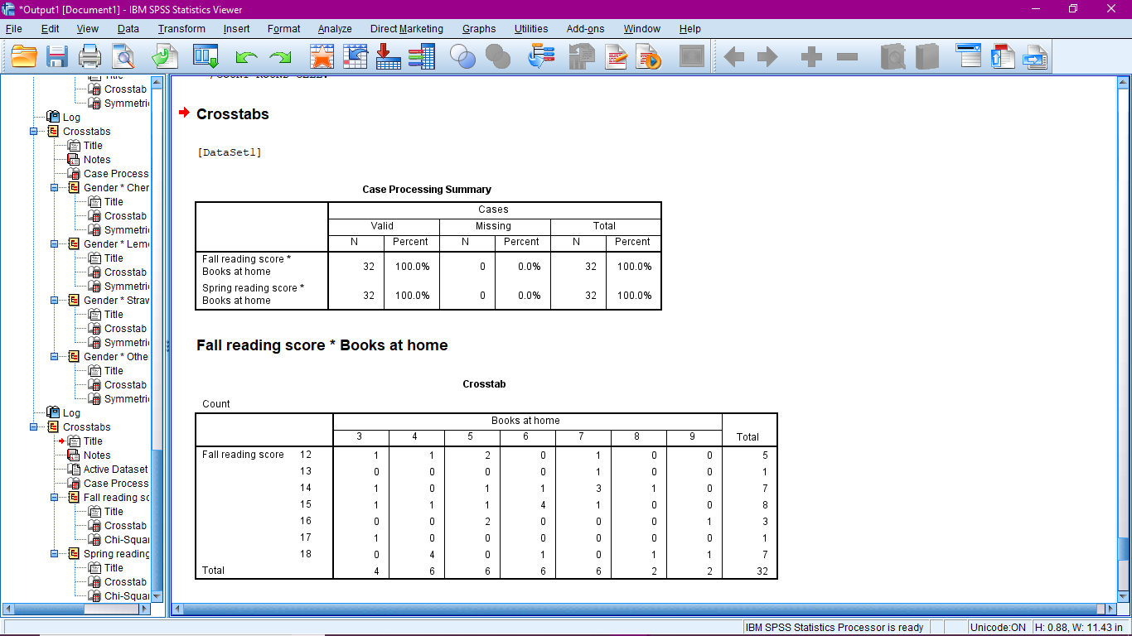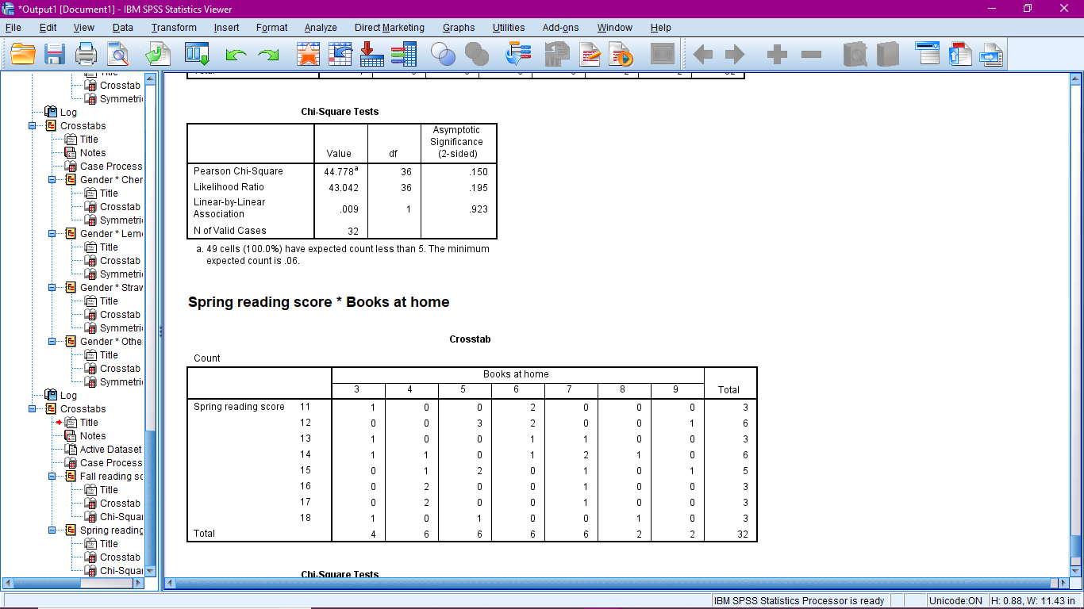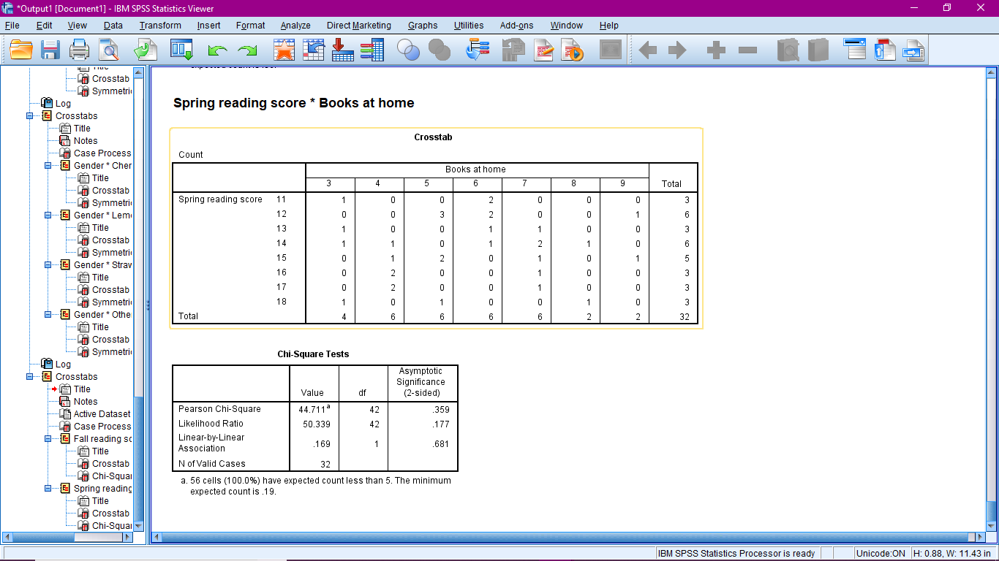

Here we have categorical data and to find association we are going to apply Chi Square Test

1. **In the first scenario i.e. between fall reading score*books at home**

Chi square value = 44.778, df = 36 and p = .150

Here the value of p i.e. 0.150 is greater than the 0.05 (5% significance level) that means our result is statistically not significant and we will accept the Null hypothesis that says there is no significant association among the data sample, that means our two categorical variables are independent of each other.

1. **In the second scenario i.e. between spring reading score*books at home**

Chi square value = 44.711, df = 42 and p = .359

Here the value of p i.e. 0.359 is greater than the 0.05 (5% significance level) that means our result is statistically not significant and we will accept the Null hypothesis that says there is no significant association among the data sample, that means our two categorical variables are independent of each other.